ToMI-2 Self-Report Interview Template
Tiffany L. Hutchins & Patricia A. Prelock © 2016
This template was developed for use with the Theory of Mind Inventory-2 (ToMI-2) for the purposes of exploring theory of mind strength and challenge areas as revealed by results of the ToMI-2. This document may be downloaded, adapted, and shared for professional purposes provided that the names and copyright appearing in this header are retained.

Client Name: __________________________
Client Age:_____________________________
Date of Interview: ______________________________

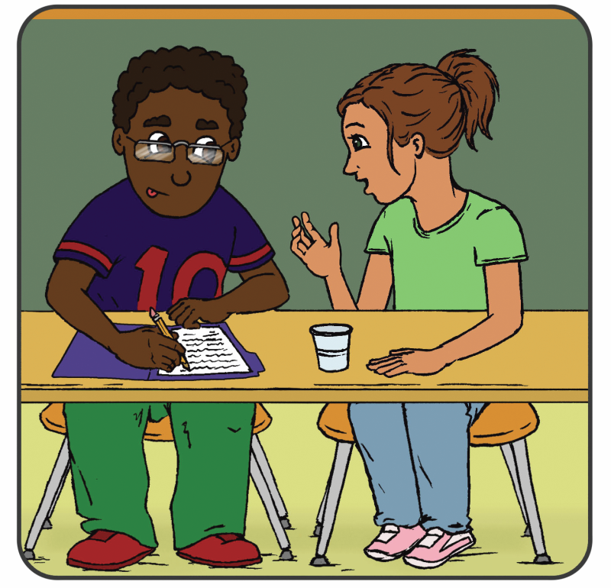
Theory of Mind is often described as ‘perspective-taking’ but it can be generally thought of as the ability to understand the thoughts and feelings of one’s self and others. There is a lot that falls under the heading of ‘Theory of Mind’. You completed a measure that asked you to rate different aspects of Theory of Mind for you. Some items you rated as “not developed”, other items you were “undecided” about, and other items you rated as pretty “developed”. For the first part of this interview, I want to ask you about a couple of the items you rated as “not developed”. After that, I have a couple questions about the items you rated as “undecided” or “developed.”
SELF-REPORT INTERVIEW PART I: UNDEVELOPED
Looking at the results, you were pretty sure that you have not developed these aspects of theory of mind. Here are the items I wanted to explore with you.
CLINICIAN: see the Table for Treatment Planning (i.e., the table at the end of the ToMI-2 report) and orient to left-most column in the bottom row of the table. Choose the items you want to explore in Part 1 of the interview from that cell only. Then open the “ToMI-2 Quick View” document and cut and paste those items here (the ToMI-2 Quick View document is found by navigating to the “Caregiver Interview” link on your dashboard). After cutting and pasting the relevant items into this template, the items should look like this:

18. I understand the difference between when a friend is teasing in a nice way and when a bully is making fun of someone in a mean way. (Advanced: complex social judgment)
36. If my friend said “What is black, white and ‘read’ all over? It’s a newspaper!” I would understand the humor in this play on words. (Advanced: humor-play on words)
PROMPT: Now we are going to briefly think about at each item and I’d like you to tell me about your experiences. Sometimes it is hard to remember the reasons behind your thinking. To the best of your ability, please describe why you believe you have not acquired this skill or give an example when you noticed that this was difficult for you.
CLINICIAN: Now, cut and paste each item for Part 1 into the spaces below so that each item above is followed by the question: What does _____ say or do, or note say or do, that shows you that this skill is not yet acquired? It should look like this:
18. I understand the difference between when a friend is teasing in a nice way and when a bully is making fun of someone in a mean way. (Advanced: complex social judgment)
When did you notice that this was difficult for you? ____________________________________________________________________________________________________________________________________________________________________________________________________________________________________________________________________________________________________________________________________________________________________
36. If my friend said “What is black, white and ‘read’ all over? It’s a newspaper!” I would understand the humor in this play on words. (Advanced: humor-play on words)
When did you notice that this was difficult for you?
____________________________________________________________________________________________________________________________________________________________________________________________________________________________________________________________________________________________________________________________________________________________________
SELF-REPORT INTERVIEW PART 2: UNDECIDED
Now I’d like to talk about things you were undecided about. Reviewing more results, you were undecided about whether you had acquired some aspects of theory of mind. Here are the items I wanted to explore with you.
CLINICIAN: see the Table for Treatment Planning and orient to center column in the bottom row of the table. Choose the items you want to explore in Part 2 of the interview from that cell only and insert those items here. After cutting and pasting the relevant items into this template, the items should look like this:

14. I understand that people can lie to purposely mislead others. (Advanced: deception by others)
45. I speak differently to young children versus adults (e.g., use simpler language or higher pitch when speaking to youngsters). (Advanced: audience adaptation)
PROMPT: Now let’s briefly think about each of these. I’d like you to tell me about your uncertainty around each of them. It is important to figure out why you felt uncertain. It could be because the item didn’t make sense, or you haven’t been in a situation recently where you’ve had to think about this. It may also be because there are certain circumstances where you feel like you understand something and others when you don’t.
CLINICIAN: Now, cut and paste each item for Part 2 into the highlighted spaces below so that each item above is followed by the relevant questions for Part 2. It should look like this:
14. I understand that people can lie to purposely mislead others. (Advanced: deception by others)
□ unsure because the item didn’t make sense or I just haven’t thought about that recently
-OR-
□ unsure because I understand this in some settings but not others, or it depends on how you think about it. If so, think of a situation where you felt you understood this and one where you did. What happened in each?
____________________________________________________________________________________________________________________________________________________________________________________________________________________________________________________________________________________________________________________________________________________________________
45. I speak differently to young children versus adults (e.g., uses simple language or higher pitch when speaking to youngsters). (Advanced: audience adaptation)
□ unsure because the item didn’t make sense or I just haven’t thought about that recently
-OR-
□ unsure because I understand this in some settings but not others, or it depends on how you think about it. If so, think of a situation where you felt you understood this and one where you did. What happened in each?
____________________________________________________________________________________________________________________________________________________________________________________________________________________________________________________________________________________________________________________________________________________________________

SELF-REPORT INTERVIEW PART 3: PROBABLY DEVELOPED
Considering the results some more, you were probably sure but not definitely sure that you had developed these aspects of theory of mind. Here are the items I wanted to explore with you:
CLINICIAN: see the Table for Treatment Planning and orient to right-most column in the bottom row of the table. Choose the items you want to explore in Part 3 of the interview from that cell only and insert those items here. After cutting and pasting the relevant items into this template, the items should look like this:
2. If it was raining and my friend said in a sarcastic voice “Gee, looks like a really nice day outside,” I would understand that they didn’t actually think it was a nice day. (Advanced: sarcasm)
13. If my friend said “Let’s hit the road!” I would understand that they really meant “Let’s go!” (Advanced: idiomatic language)
GENERAL KEY QUESTION: Even though you were not definitely sure, it looks like you pretty sure that you understood these things. Nevertheless, is there anything I should know about your understanding in any of these areas? Do you have any concerns about development? Do you think more could be done to strengthen these areas even further?
_________________________________________________________________________________________________________________________________________________________________________________________________________________________________________________________________________________________________________________________________________________________________________________________________________________________________________________________________________________________________________________________________________________________________________________________________________________________________________________________________________________________________________________________________________________________________________________________________________________________________

GENERAL QUESTION: Thinking about your readiness and your own priorities for developing your theory of mind skills, what would be your treatment priorities?

- ______________________________________________________

- ______________________________________________________

- ______________________________________________________

- ______________________________________________________

GENERAL QUESTION: Is there anything else you would like to tell me about your theory of mind?
_________________________________________________________________________________________________________________________________________________________________________________________________________________________________________________________________________________________________________________________________________________________________________________________________________________________________________________________________________________________________________________________________________________________________________________________________________________________________________________________________________________________________________________________________________________________________________________________________________________________________________________________________________________________________________________________________________________________________________________________________________________________________________________________________________________________________________________________________________________________________________________________________________________________________________________________________________________________________________________________________________________________________________________________________________________________________________________________________________________________________________________________________________________________________________

-End-

