ToMI-2 Quick View: Self-Report
Tiffany L. Hutchins & Patricia A. Prelock © 2016
This template was developed for use with the Theory of Mind Inventory-2 (ToMI-2) for the purposes of exploring theory of mind strength and challenge areas as revealed by results of the ToMI-2. This document may be downloaded, adapted, and shared for professional purposes provided that the names and copyright appearing in this header are retained.

The ToMI-2 Quick View provides a quick and easy way for inserting item language into the ToMI-2 Self-Report Interview Template. Be sure to follow the instructions on the template when determining the location of items into the interview: which items you choose depend on which aspects you wish to explore and where they are inserted into the template depends on the results from the Table for Treatment Planning.

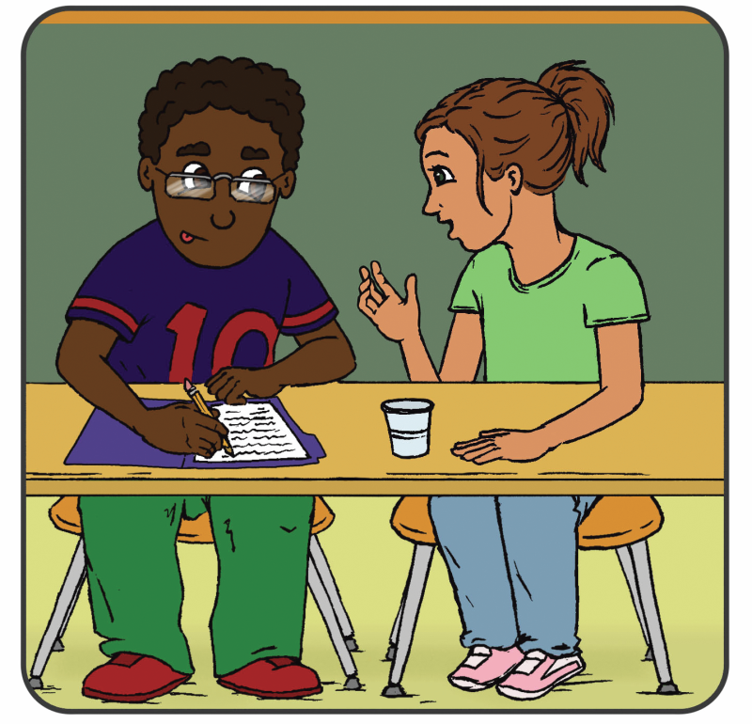

ToMI-2 ITEM CONTENT:
number, Item, subscale (early, basic, advanced), and domain
- I child understand that when someone puts on a jacket, it is probably because he/she is cold. (Basic subscale: physiologically-based behavior)

- If it was raining and someone said in a sarcastic voice “Gee, looks like a really nice day outside,” I would understand that that person didn’t actually think it was a nice day. (Advanced subscale: Pragmatics: sarcasm)
- I recognize when someone needs help. (Early subscale: early empathy)

- I understand that when someone says they are afraid of the dark, they will not want to go into a dark room. (Basic subscale: emotion-based behavior)

- I understand that people can be wrong about what other people want.(Advanced: second-order false desire attribution)

- I understand that when people frown, they feel differently than when they smile. (Early subscale: discrimination of basic emotions)

- I understand the word ‘think’ (Basic subscale: mental state term comprehension: cognitive terms: think)

- If my friend put his keys on the table, left the room, and I moved the keys from the table to a drawer, I would understand that when he returned, he would first look for his keys where he left them. (Basic subscale: false beliefs: unexpected location)

- I understand that to know what is in an unmarked box, you have to see or hear about what is in that box. (Basic subscale: seeing-leads-to-knowing)

- I understand the word ‘know’. (Basic subscale: mental state term comprehension: cognitive terms: know)

- Appearances can be deceiving. For example, when seeing a candle shaped like an apple, some people first assume that the object is an apple. Given the chance to examine it more closely, people typically change their mind and decide that the object is actually a candle. If I was in this situation, I would understand that it was not the object that changed, but rather my ideas about the object that changed. (Basic subscale: appearance-reality distinction)

- If my friend showed me a cereal box filled with cookies and asked “What would someone who has not looked inside think is in the box?”, I would say that another person would think that there was cereal in the box. (Basic subscale: false beliefs: unexpected contents)

- If my friend said “Let’s hit the road!” I would understand that they really meant “Let’s go!” (Advanced subscale: pragmatics: idiomatic language)

- I understand that people can lie to purposely mislead others. (Advanced subscale: pragmatics: deception by others)

- I understand that when someone makes a ‘guess’ it means they are less certain than when they ‘know’ something. (Basic subscale: certainty)

- I understand that when someone is thinking about a cookie, they cannot actually smell, eat or share that cookie. (Basic subscale: mental-physical distinction)

- I understand that people can smile even when they are not happy. (Advanced subscale: display rules)

- I understand the difference between when a friend is teasing in a nice way and when a bully is making fun of someone in a mean way. (Advanced subscale: complex social judgment)

- I understand that people don’t always say what they are thinking because they don’t want to hurt others’ feelings. (Advanced subscale: white lies)

- I understand the difference between lies and jokes. (Advanced subscale: lies v. jokes)

- I understand that if two people look at the same object from a different standing point, they will see the object in different ways. (Advanced subscale: visual perspective-taking: level 2)

- I understand that people often have thoughts about other peoples’ thoughts. (Advanced subscale: second-order understanding of belief)

- I understand that people often have thoughts about other peoples’ feelings. (Advanced subscale: second-order understanding of emotion)

- I understand whether someone hurts another on purpose or by accident. (Early subscale: intentionality)

- I recognize when others are happy. (Early subscale: basic positive emotion recognition: happy)

- I can pretend that one object is a different object (for example, pretending a banana is a telephone). (Basic subscale: pretense: engaging in pretense)

- I recognize when a listener is not interested. (Advanced subscale: complex social judgment)

- I understand that, when someone else shows fear, the situation is unsafe or dangerous. (Early subscale: social referencing: reading fear)

- I understand the word ‘if’ when it is used hypothetically as in, “If I had the money, I’d buy a new house.” (Basic subscale: counterfactual reasoning)

- I understand that when a person uses his/her hands as a bird, that the person doesn’t actually think it is a real bird. (Basic subscale: pretense: understanding pretense in others)

- I understand that when a person uses his/her hands as a bird, that the person doesn’t actually think it is a real bird. (Basic subscale: pretense: understanding pretense in others)

- I recognize when others feel disgusted. (Basic subscale: cognitive emotion recognition: disgust)

- I understand that when a person promises something, it means the person is supposed to do it. (Basic subscale: speech acts: performatives: promise)

- I am able to put myself in other people’s shoes and understand how they feel. (Advanced subscale: true empathy)

- I understand that when someone shares a secret, you are not supposed to tell anyone. (Basic subscale: pragmatics: secrets)

- If my friend said “What is black, white and ‘read’ all over? It’s a newspaper!” I would understand the humor in this play on words. (Advanced: pragmatics: humor: play on words)

- I am able to show people things. (Early subscale: sharing attention: initiating)

- I am able to pay attention when someone shows me something. (Early subscale: sharing attention: responding)

- I understand the word ‘believe’. (Basic subscale: mental state term comprehension: cognitive terms: believe)

- When we like others, we are likely to interpret their behavior in positive ways and when we don’t like others, we are likely to interpret their behavior more negatively. I understand that previous ideas and/or opinions of others can influence how we interpret their behaviors. (Advanced subscale: interpretive theory of mind: biased cognition)

- I understand that two people can see the same image and interpret it differently. For example, when looking at this image, one person might see a rabbit whereas another might see a duck. (Advanced subscale: interpretive theory of mind: ambiguous figure perception)

- I understand that if Bruce is a mean boy and John is a nice boy, Bruce is more likely than John to engage in malicious or hurtful behaviors. (Basic subscale: attribute-based behavior)

- If my friend looked up and stared at the sky, I would also look up to see what I was looking at. (Early subscale: gaze following)

- If I saw a strange new object, I would look to someone else and check their reaction before touching it. (Early subscale: social referencing: ambiguous situation)

- I speak differently to young children versus adults (e.g., use simpler language or higher pitch when speaking to youngsters). (Advanced subscale: pragmatics: audience adaptation)

- I understand that it is possible to experience two conflicting emotions at the same time (e.g., being sad that a sick pet died but being happy that it is no longer in pain). (Advanced subscale: mixed emotions)

- I understand that an unfamiliar adult can make good guesses about my likes and dislikes (e.g., an unfamiliar adult might correctly guess that the child doesn’t like to clean his/her room). (Advanced subscale: common sense: social knowledge)

- I recognize when others are sad. (Early subscale: basic negative emotion recognition: sad)

- I recognize when others are mad. (Early subscale: basic negative emotion recognition: mad)

- I recognize when others are scared. (Early subscale: basic negative emotion recognition: scared)

- I recognize when others are surprised (Basic subscale: cognitive emotion recognition: surprise)

- I recognize when others feel embarrassed. (Advanced subscale: complex emotion recognition: embarrassed)

- I understand the word “need”. (Basic subscale: mental state term comprehension: desire terms: need)

- I understand the word “want”. (Early subscale: mental state term comprehension: desire terms: want)

- I recognize when others feel guilty. (Advanced subscale: complex emotion recognition: guilt)

- I can accurately identify and reflect upon my own emotional states. (Advanced subscale: emotional introspection)

- I can predict my own emotions to better plan for the future (e.g., if spending the night away from home, I know I might get bored so I bring something to do). (Basic subscale: future thinking)

- I understand what people think and feel by connecting it to the situation (e.g., crying because you lost a game is different than crying because you won an award). (Advanced subscale: situation-based disambiguation of emotion)

- I understand that other people are happy when they get what they want. (Early subscale: desire-based emotion)

- I understand that beliefs can cause emotions (e.g., understanding that Patty is happy because she thinks she is going to win an award). (Basic subscale: belief-based emotion)

