ToMI-2 Quick View
Tiffany L. Hutchins & Patricia A. Prelock © 2016
This template was developed for use with the Theory of Mind Inventory-2 (ToMI-2) for the purposes of exploring theory of mind strength and challenge areas as revealed by results of the ToMI-2. This document may be downloaded, adapted, and shared for professional purposes provided that the names and copyright appearing in this header are retained.

The ToMI-2 Quick View provides a quick and easy way for inserting item language into the ToMI-2 Caregiver Interview Template. Be sure to follow the instructions on the template when determining the location of items into the interview: which items you choose depend on which aspects you wish to explore and where they are inserted into the template depends on the results from the Table for Treatment Planning.

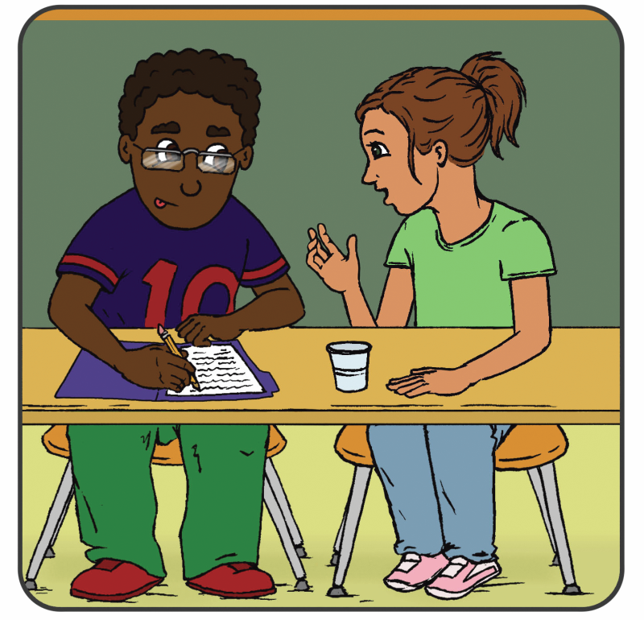

ToMI-2 ITEM CONTENT:
number, Item, subscale (early, basic, advanced), and domain
- My child understands that when someone puts on a jacket, it is probably because he/she is cold. (Basic subscale: physiologically-based behavior)

- If it was raining and I said in a sarcastic voice “Gee, looks like a really nice day outside,” my child would understand that I didn’t actually think it was a nice day. (Advanced subscale: Pragmatics: sarcasm)
- My child recognizes when someone needs help. (Early subscale: early empathy)

- My child understands that when someone says they are afraid of the dark, they will not want to go into a dark room. (Basic subscale: emotion-based behavior)

- My child understands that people can be wrong about what other people want.(Advanced: second-order false desire attribution)

- My child understands that when people frown, they feel differently than when they smile. (Early subscale: discrimination of basic emotions)

- My child understands the word ‘think’ (Basic subscale: mental state term comprehension: cognitive terms: think)

- If I put my keys on the table, left the room, and my child moved the keys from the table to a drawer, my child would understand that when I returned, I would first look for my keys where I left them. (Basic subscale: false beliefs: unexpected location)

- My child understands that to know what is in an unmarked box, you have to see or hear about what is in that box. (Basic subscale: seeing-leads-to-knowing)

- My child understands the word ‘know’. (Basic subscale: mental state term comprehension: cognitive terms: know)

- Appearances can be deceiving. For example, when seeing a candle shaped like an apple, some people first assume that the object is an apple. Given the chance to examine it more closely, people typically change their mind and decide that the object is actually a candle. If my child was in this situation, my child would understand that it was not the object that changed, but rather his or her ideas about the object that changed. (Basic subscale: appearance-reality distinction)

- If I showed my child a cereal box filled with cookies and asked “What would someone who has not looked inside think is in the box?”, my child would say that another person would think that there was cereal in the box. (Basic subscale: false beliefs: unexpected contents)

- If I said “Let’s hit the road!” my child would understand that I really meant “Let’s go!” (Advanced subscale: pragmatics: idiomatic language)

- My child understands that people can lie to purposely mislead others. (Advanced subscale: pragmatics: deception by others)

- My child understands that when someone makes a ‘guess’ it means they are less certain than when they ‘know’ something. (Basic subscale: certainty)

- My child understands that when someone is thinking about a cookie, they cannot actually smell, eat or share that cookie. (Basic subscale: mental-physical distinction)

- My child understands that people can smile even when they are not happy. (Advanced subscale: display rules)

- My child understands the difference between when a friend is teasing in a nice way and when a bully is making fun of someone in a mean way. (Advanced subscale: complex social judgment)

- My child understands that people don’t always say what they are thinking because they don’t want to hurt others’ feelings. (Advanced subscale: white lies)

- My child understands the difference between lies and jokes. (Advanced subscale: lies v. jokes)

- My child understands that if two people look at the same object from a different standing point, they will see the object in different ways. (Advanced subscale: visual perspective-taking: level 2)

- My child understands that people often have thoughts about other peoples’ thoughts. (Advanced subscale: second-order understanding of belief)

- My child understands that people often have thoughts about other peoples’ feelings. (Advanced subscale: second-order understanding of emotion)

- My child understands whether someone hurts another on purpose or by accident. (Early subscale: intentionality)

- My child recognizes when others are happy. (Early subscale: basic positive emotion recognition: happy)

- My child can pretend that one object is a different object (for example, pretending a banana is a telephone). (Basic subscale: pretense: engaging in pretense)

- My child recognizes when a listener is not interested. (Advanced subscale: complex social judgment)

- My child understands that, when I show fear, the situation is unsafe or dangerous. (Early subscale: social referencing: reading fear)

- My child understands the word ‘if’ when it is used hypothetically as in, “If I had the money, I’d buy a new house.” (Basic subscale: counterfactual reasoning)

- My child understands that when a person uses his/her hands as a bird, that the person doesn’t actually think it is a real bird. (Basic subscale: pretense: understanding pretense in others)

- My child understands that when a person uses his/her hands as a bird, that the person doesn’t actually think it is a real bird. (Basic subscale: pretense: understanding pretense in others)

- My child recognizes when others feel disgusted. (Basic subscale: cognitive emotion recognition: disgust)

- My child understands that when a person promises something, it means the person is supposed to do it. (Basic subscale: speech acts: performatives: promise)

- My child is able to put himself/herself in other people’s shoes and understand how they feel. (Advanced subscale: true empathy)

- My child understands that when someone shares a secret, you are not supposed to tell anyone. (Basic subscale: pragmatics: secrets)

- If I said “What is black, white and ‘read’ all over? It’s a newspaper!” my child would understand the humor in this play on words. (Advanced: pragmatics: humor: play on words)

- My child is able to show me things. (Early subscale: sharing attention: initiating)

- My child is able to pay attention when I show him/her something. (Early subscale: sharing attention: responding)

- My child understands the word ‘believe’. (Basic subscale: mental state term comprehension: cognitive terms: believe)

- When we like others, we are likely to interpret their behavior in positive ways and when we don’t like others, we are likely to interpret their behavior more negatively. My child understands that previous ideas and/or opinions of others can influence how we interpret their behaviors. (Advanced subscale: interpretive theory of mind: biased cognition)

- My child understands that two people can see the same image and interpret it differently. For example, when looking at this image, one person might see a rabbit whereas another might see a duck. (Advanced subscale: interpretive theory of mind: ambiguous figure perception)

- My child understands that if Bruce is a mean boy and John is a nice boy, Bruce is more likely than John to engage in malicious or hurtful behaviors. (Basic subscale: attribute-based behavior)

- If I looked up and stared at the sky, my child would also look up to see what I was looking at. (Early subscale: gaze following)

- If my child saw a strange new object, he/she would look to me and check my reaction before touching it. (Early subscale: social referencing: ambiguous situation)

- My child speaks differently to young children versus adults (e.g., uses simple language or higher pitch when speaking to youngsters). (Advanced subscale: pragmatics: audience adaptation)

- My child understands that it is possible to experience two conflicting emotions at the same time (e.g., being sad that a sick pet died but being happy that it is no longer in pain). (Advanced subscale: mixed emotions)

- My child understands that an unfamiliar adult can make good guesses about my child’s likes and dislikes (e.g., an unfamiliar adult might correctly guess that the child doesn’t like to clean his/her room). (Advanced subscale: common sense: social knowledge)

- My child recognizes when others are sad. (Early subscale: basic negative emotion recognition: sad)

- My child recognizes when others are mad. (Early subscale: basic negative emotion recognition: mad)

- My child recognizes when others are scared. (Early subscale: basic negative emotion recognition: scared)

- My child recognizes when others are surprised (Basic subscale: cognitive emotion recognition: surprise)

- My child recognizes when others feel embarrassed. (Advanced subscale: complex emotion recognition: embarrassed)

- My child understands the word “need”. (Basic subscale: mental state term comprehension: desire terms: need)

- My child understands the word “want”. (Early subscale: mental state term comprehension: desire terms: want)

- My child recognizes when others feel guilty. (Advanced subscale: complex emotion recognition: guilt)

- My child can accurately identify and reflect upon his/her own emotional states. (Advanced subscale: emotional introspection)

- My child can predict his/her own emotions to better plan for the future (e.g., if spending the night away from home, the child knows he will miss mom and so he brings his favorite blanket for comfort). (Basic subscale: future thinking)

- My child understands what people think and feel by connecting it to the situation (e.g., my child understands that crying because you lost a game is different than crying because you won an award). (Advanced subscale: situation-based disambiguation of emotion)

- My child understands that other people are happy when they get what they want. (Early subscale: desire-based emotion)

- My child understands that beliefs can cause emotions (e.g., understanding that Patty is happy because she thinks she is going to win an award). (Basic subscale: belief-based emotion)

