ToMI-2 Caregiver Interview Template
Tiffany L. Hutchins & Patricia A. Prelock © 2016
This template was developed for use with the Theory of Mind Inventory-2 (ToMI-2) for the purposes of exploring theory of mind strength and challenge areas as revealed by results of the ToMI-2. This document may be downloaded, adapted, and shared for professional purposes provided that the names and copyright appearing in this header are retained.

Student/Client Name: __________________________
Caregiver’s Name:______________________________
Student/Client Age:_____________________________
Date of Interview: ______________________________

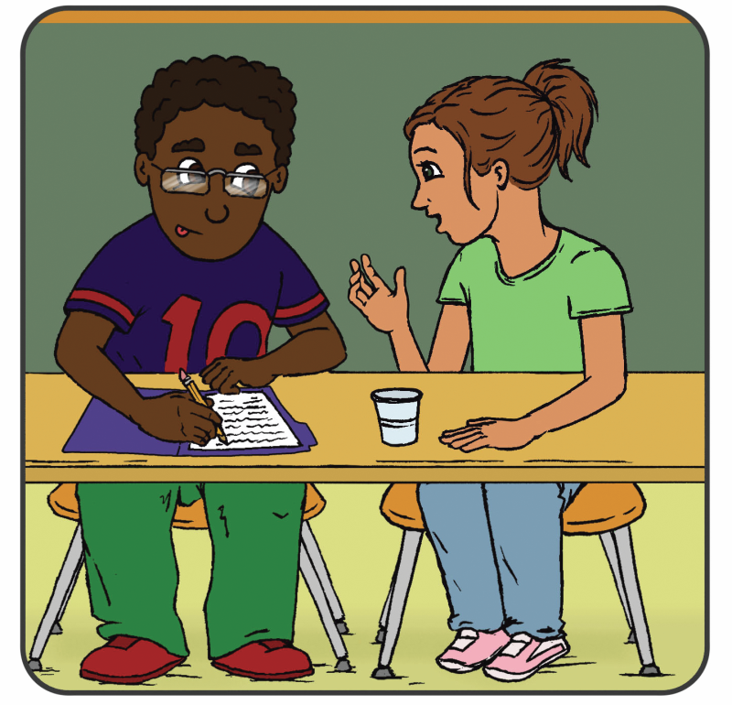
Theory of Mind is often described as ‘perspective-taking’ but it can be generally thought of as the ability to understand the thoughts and feelings of one’s self and others. There is a lot that falls under the heading of ‘Theory of Mind’. You completed a measure that asked you to rate different aspects of Theory of Mind for your child. Some items you rated as “not developed”, other items you were “undecided” about, and other items you rated as pretty “developed”. For the first part of this interview, I want to ask you about a couple of the items you rated as “not developed”. After that, I have a couple questions about the items you rated as “undecided” or “developed.”
CAREGIVER INTERVIEW PART I: UNDEVELOPED
Looking at the results, you were pretty sure that ____________ had not developed these aspects of theory of mind, however, these areas are expected given ________’s age. Here are the items I wanted to explore with you.
CLINICIAN: see the Table for Treatment Planning (i.e., the table at the end of the ToMI-2 report) and orient to left-most column in the bottom row of the table. Choose the items you want to explore in Part 1 of the interview from that cell only. Then open the “ToMI-2 Quick View” document and cut and paste those items here (the ToMI-2 Quick View document is found by navigating to the “Caregiver Interview” link on your dashboard). After cutting and pasting the relevant items into this template, the items should look like this:

18. My child understands the difference between when a friend is teasing in a nice way and when a bully is making fun of someone in a mean way. (Advanced: complex social judgment)
36. If I said “What is black, white and ‘read’ all over? It’s a newspaper!” my child would understand the humor in this play on words. (Advanced: humor-play on words)
PROMPT: Now we are going to briefly think about at each item and I’d like you to tell me about your experiences. Sometimes it is hard to remember the reasons behind your thinking. To the best of your ability, please describe why you believe ________ has not acquired this skill or give an example when you noticed that __________ was not demonstrating this skill.
CLINICIAN: Now, cut and paste each item for Part 1 into the spaces below so that each item above is followed by the question: What does _____ say or do, or note say or do, that shows you that this skill is not yet acquired? It should look like this:
18. My child understands the difference between when a friend is teasing in a nice way and when a bully is making fun of someone in a mean way. (Advanced: complex social judgment)
What does __________ say or do, or not say or do, that shows you that this skill is not yet acquired?
____________________________________________________________________________________________________________________________________________________________________________________________________________________________________________________________________________________________________________________________________________________
36. If I said “What is black, white and ‘read’ all over? It’s a newspaper!” my child would understand the humor in this play on words. (Advanced: humor-play on words)
What does __________say or do, or not say or do, that shows you that this skill is not yet acquired?
____________________________________________________________________________________________________________________________________________________________________________________________________________________________________________________________________________________________________________________________________________________________________

CAREGIVER INTERVIEW PART 2: UNDECIDED
Now I’d like to talk about things you were undecided about. Reviewing more results, you were undecided about whether __________ had acquired some aspects of theory of mind; however, these aspects are expected given ______’s age. Here are the items I wanted to explore with you.
CLINICIAN: see the Table for Treatment Planning and orient to center column in the bottom row of the table. Choose the items you want to explore in Part 2 of the interview from that cell only and insert those items here. After cutting and pasting the relevant items into this template, the items should look like this:

14. My child understands that people can lie to purposely mislead others. (Advanced: deception by others)
45. My child speaks differently to young children versus adults (e.g., uses simple language or higher pitch when speaking to youngsters). (Advanced: audience adaptation)
PROMPT: Now let’s briefly think about each of these items. I’d like you to tell me about your uncertainty around each of them. It is important to figure out why. It could be because the item didn’t make sense, or you haven’t seen __________ in a recent situation where the skill could be observed, or you aren’t sure what having this skill might look like for ________. It may also be because sometimes __________ seems to have this skill and sometimes he doesn’t.
CLINICIAN: Now, cut and paste each item for Part 2 into the highlighted spaces below so that each item above is followed by the relevant questions for Part 2. It should look like this:
14. My child understands that people can lie to purposely mislead others. (Advanced: deception by others)
□ unsure because the item didn’t make sense, you haven’t seen __________ in this situation recently, or you don’t know what this skill would look like in __________
-OR-
□ unsure because __________shows this skill in some settings but not others, or it depends on how you think about it. If so, think of a situation where you observed the skill and another situation where __________ did not demonstrate the skill – OR – think of a time when __________ have demonstrated this skill but didn’t. What happened?
____________________________________________________________________________________________________________________________________________________________________________________________________________________________________________________________________________________________________________________________________________________
45. My child speaks differently to young children versus adults (e.g., uses simple language or higher pitch when speaking to youngsters). (Advanced: audience adaptation)
□unsure because the item didn’t make sense, you haven’t seen __________ in this situation recently, or you don’t know what this skill would look like in __________?
-OR-
□ unsure because __________ shows this skill in some settings but not others, or it depends on how you think about it. If so, think of a situation where you observed the skill and another situation where __________ did not demonstrate the skill – OR – think of a time when __________ have demonstrated this skill but didn’t. What happened?
____________________________________________________________________________________________________________________________________________________________________________________________________________________________________________________________________________________________________________________________________________________________________

CAREGIVER INTERVIEW PART 3: PROBABLY DEVELOPED
Considering the results some more, you were probably sure but not definitely sure that __________ had developed these aspects of theory of mind and these aspects are expected given _________’s age. Here are the items I wanted to explore with you:
CLINICIAN: see the Table for Treatment Planning and orient to right-most column in the bottom row of the table. Choose the items you want to explore in Part 3 of the interview from that cell only and insert those items here. After cutting and pasting the relevant items into this template, the items should look like this:
2. If it was raining and I said in a sarcastic voice “Gee, looks like a really nice day outside,” my child would understand that I didn’t actually think it was a nice day. (Advanced: sarcasm)
13. If I said “Let’s hit the road!” my child would understand that I really meant “Let’s go!” (Advanced: idiomatic language)
GENERAL KEY QUESTION: Even though you were not definitely sure, it looks like you thought _______ probably had these skills so it seems _________ has some strength in these areas. Nevertheless, is there anything I should know about __________’s development in any of these areas? Do you have any concerns about development? Do you think more could be done to strengthen these areas even further?
_________________________________________________________________________________________________________________________________________________________________________________________________________________________________________________________________________________________________________________________________________________________________________________________________________________________________________________________________________________________________________________________________________________________________________________________________________________________________________________________________________________________________________________________________________________________________________________________________________________________________

GENERAL QUESTION: Thinking about __________’s readiness and your own priorities for developing his theory of mind skills, what would be your treatment priorities?

- ______________________________________________________

- ______________________________________________________

- ______________________________________________________

- ______________________________________________________

GENERAL QUESTION: Is there anything else you would like to tell me about __________’s theory of mind?
_________________________________________________________________________________________________________________________________________________________________________________________________________________________________________________________________________________________________________________________________________________________________________________________________________________________________________________________________________________________________________________________________________________________________________________________________________________________________________________________________________________________________________________________________________________________________________________________________________________________________________________________________________________________________________________________________________________________________________________________________________________________________________________________________________________________________________________________________________________________________________________________________________________________________________________________________________________________________________________________________________________________________________________________________________________________________________________________________________________________________________________________________________________________________________

-End-

